Marbury Update March 2025
Budget Council 2025 - 26
Conservative Councillors made every effort to improve the financial impact on residents
February’s Budget Council on the 20th February 2025, we took the administration to task over failures in service delivery and financial planning for the 2025/26 financial year.
In our opinion the budget presents risk, stating a funding gap of £49m, that will be bridged by cuts/efficiencies of £29m, and raising an additional locally generated income of £20m from Council Tax and Business Rates.
Residents will be suffering a council tax increase whilst seeing a reduction in services, and the disadvantaged in our borough will be suffering the most. We again raised concerns for residents seeing increased National & Local taxes for yet another year.
Too many pensioners have already lost their Winter Fuel Allowance and the rise in Employers National Insurance will impact employment in the area. Despite this the Labour Group voted through a maximum 4.99% increase – yet again! That’s 10 consecutive years of maximum rises, making this council the 32nd highest out of 317 councils.
Overall, this leads to an extra £650 per year on a Band D property since the Labour Administration came to power in 2015

Amendments Proposed by our Group
We put forward two credible and fully funded amendments and budget speeches focused on the many failures of the council to invest in our highways.
- 20mph limits outside all schools across Cheshire West & Chester (24 schools will be impacted) - Agreed
- Additional (£425k) budget allocation for siding out pathways and gully clearance – Refused. This was a real ‘spend to save’ proposal, so disappointed that it was dismissed by the Administration.

Summary of National issues impacting locally:
- Farm Inheritance Tax – impacting many Families in our communities. Along with Esther McVey MP, we continue to voice concern and the ramifications of this on our farming community. Supported/ attended the farmers day in Chester
- Min Wage + NI Changes – this comes into effect next month – clear impact on SMEs / High Street and hospitality as well as larger businesses operating in the Borough. Impact on council costs and income is yet to be seen. We have concerns that this has been underestimated in the Council Budget setting.

Devolution – Cheshire & Warrington
Devolution – the government consultation is on-going (it’s long) - Cheshire and Warrington devolution consultation - GOV.UK. This is a statutory consultation which always happens when local areas go for devolution and the results are NOT shared with the local authorities. It begs the question as to why anyone would respond to it…. Following the government consultation, there will be a local one (which will be more of a conversation or so we are told….). Expect citizen panels and the like etc.
- As yet there is no real idea of what monies may or may not be coming to CWaC etc to fund devolution – so far, the LEP has been raided with the expectation the money will be replaced further down the line and there are likely to be quite a few upfront costs to this process so there are questions as to where this comes from (potentially from Council pots).
- A Shadow Combined Authority will need to be in place by the end of the year – and we expect the vote on the formal devolution deal to happen at July Full Council.
- With regards to wider LGR, Halton is staying in LCR and Cheshire West and Cheshire East definitely won’t be going through any restructuring (which is contrary to some reports I heard – which is positive).
- Mayoral Elections – May 2026

Devolution Consultation open – closing 13th April 2025 at 23:59
Links below:
https://www.gov.uk/government/consultations/cheshire-and-warrington-devolution/cheshire-and-warrington-devolution-consultation
https://www.cheshirewestandchester.gov.uk/news/cheshire-and-warrington-devolution-have-your-say
https://www.cheshireandwarringtondevolution.com
Northwich

Flooding
We are continuing to work with officers, Kath McArdle (the new Director of Place), Parish Councils, residents and landowners to implement some long-term solutions to the growing number of Flooding hot spots across the ward.
Current target areas include:
Anderton – Cogshall Lane
Antrobus – Village Centre
Sutton Weaver – Chester Rd (Meadowbank Farm)
Whitley - Town Pit, Greenhill Lane, Pillmoss Lane

Pride in our Villages
Outside reporting issues and hands-on activity, we are always keen to know when Parishes are organising any litter picks or similar activity, so we can lend a hand and join you. Keep us posted.
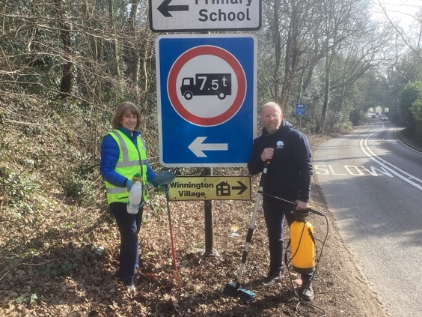
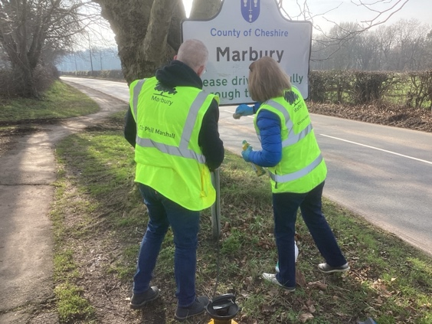
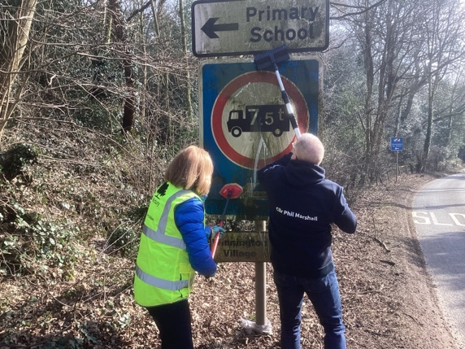
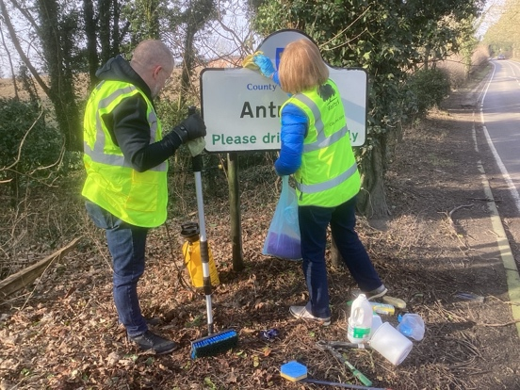
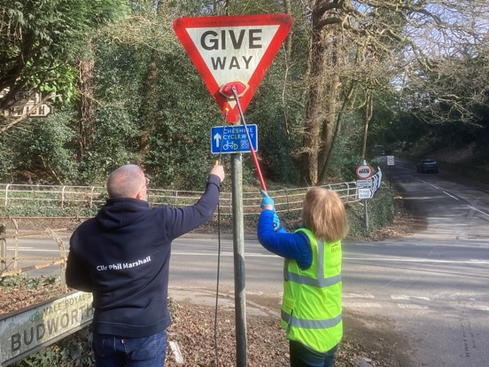
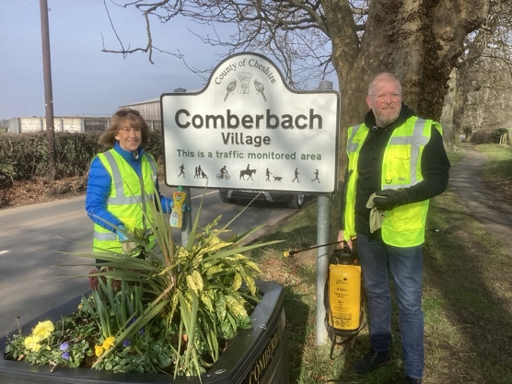
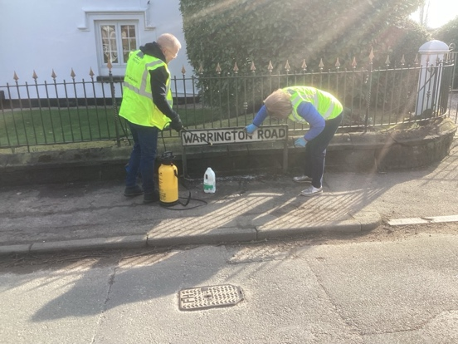

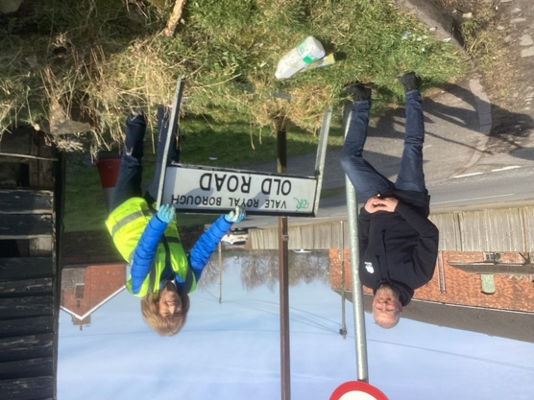
Highways
- List of intended works has been published and include many across Marbury. However, we are waiting for many more and have asked for a meeting to discuss lack of progression and a number of local issues, the Chutes and Winnington Bridge, the lack of timely maintenance, the quality of work and the length of time to undertaken submitted issues.
Fire and Rescue
- Unitary Performance Groups (UPG) Initiatives – funding for reducing deliberate fires or road safety and a variety of initiates relevant to communities across the borough – ideas will be circulated
Policing
- New ‘Hot Spot Policing’ pilot, parish councils can request for officers to patrol an area in 4 hour blocks, paid for on an officer overtime deal to address a specific, possible short term problem e.g. ASB
- SWAP – safety, working together, action, prevention fund - £200k from the proceeds of crime act (9 projects benefitted this year) Watch out for this years

Cheshire and Warrington Local Nature Recovery Strategy consultation
https://participatenow.cheshirewestandchester.gov.uk/cheshire-and-warrington-local-nature-recovery-strategy-consultation
This consultation will close on Monday 31 March.

Council Housing Tenant and Leaseholder Engagement Strategy Consultation
https://www.cheshirewestandchester.gov.uk/your-council/consultations-and-petitions/consultations/current-consultations/council-housing-tenant-leaseholder-engagement-strategy-consultation
Closing date: 5pm on Sunday 13 April 2025
Planning
Planning Policy Consultations
- Local Plan
- Design Code
- Call for Nature Investment Sites
- Neighbourhood Planning Consultation
https://consult.cheshirewestandchester.gov.uk/kse/folder/98590
National Planning Policy Framework (NPPF)
- Consultation feedback expected any time now.
- Housing numbers to be increased from current delivery of 1000 to 2100 per year in CWaC
- Further clarification required on increased building in ‘green’ belt by naming areas ‘grey’ belt and rather ambiguous definitions.
Members Budgets 2025-2026
Application for 2025 - 26 Budgets will commence April 2025.
https://www.cheshirewestandchester.gov.uk/your-council/councillors-and-committees/councillors-allowances/member-budgets
Space Hive – Reopening in April for applications
https://www.spacehive.com/movement/cwc
Other Funding Opportunities:
Funding opportunities | Cheshire West and Chester Council
- The Stobart Sustainability Fund | Stobart (eddiestobart.com)
- Rural Countryside Fund (some parts of NW will be eligible for this) Supporting Rural Communities - The Royal Countryside Fund
- Delamere Dairy Foundation (LOCAL ORGANISATION) Home - Delamere Dairy Foundation
- Grants for Charities or CIO’s - What We Fund - Bernard Sunley Foundation
- Grants for historic church interiors and churchyard structures | The Church of England
- Small Grants | Trusthouse Charitable Foundation
- Public memorial grant – for repairs/maintenance - Applying for a memorial grant - GOV.UK (www.gov.uk) ENDS 31st March 2025
- Climate Action Fund: Our Shared Future (tnlcommunityfund.org.uk)
- Aviva Community Fund Aviva Community Fund
- Veolia Funding (veoliatrust.org)
- Biffa Funding Home Page - Biffa Award
- Blue Spark Foundation – grants for projects supporting children and young people Home - Blue Spark Foundation
- Energy Resilience Fund – Power to Change

The Energy Resilience Fund is an initiative assisting community businesses in retrofitting their buildings with energy-saving measures. Energy Resilience Fund - Power to Change
- Neighbourhood Planning Grant Funding – Locality. Home - Locality Neighbourhood Planning
- Electricals Recycling Fund – Material Focus
The Electricals Recycling Fund aims to grow existing methods or test new creative and practical ones for recycling small household electrical goods. If you have a project that would make it easier for the public to repair, reuse or recycle their electricals, you can apply for funding. Electricals Recycling Fund - Material Focus
- Community Ownership Fund Community Ownership Fund Round 4: how to express your interest in applying - GOV.UK (www.gov.uk)

London Hearts has launched this scheme with the aim of increasing the number of AEDs to help save lives. Anyone in your constituency can apply, including the council. Please circulate, funding of circa £660 per unit is required.
Interested? Apply using the link below! — https://londonhearts.org/defib-scheme/
https://londonhearts.org/article/lh-launches-new-defibrillator-scheme-to-help-save-lives- across-the-uk/

Facebook Link to the Scheme to Share - https://www.facebook.com/LondonHearts1/posts/pfbid0VtehyLLPq8U3yWF5xuoztJTA5r1vrMa snEdNnnYjxRk5kPQukH3XAvZQbkKn9XTWl
Link
VCSE Energy Efficiency Scheme - Groundwork
Communities Team Web Page: Communities in action | Cheshire West and Chester Council

